Level 2 -> Level 3

The goal of this level is to use the file whose name has spaces and get the password of next level.

So now, firstly we will check the files and folders of the current directory in which we are by using **ls** command. Simple **ls** command is used to list out all the files and folder of the directory in which the user is present.

When we run **ls** command it lists the name of files present. We found the required file i.e. **spaces in this filename**. It means we are already in the home directory.

We can’t read the content of the file which has spaces in it’s name by simply using **cat** command. So to use this type of file we simply need to use **“”(double quotes) or ‘’(single quotes)** with the file name i.e. ‘**spaces in this filename’ or “spaces in this filename”**. The file contains the password for level 3.

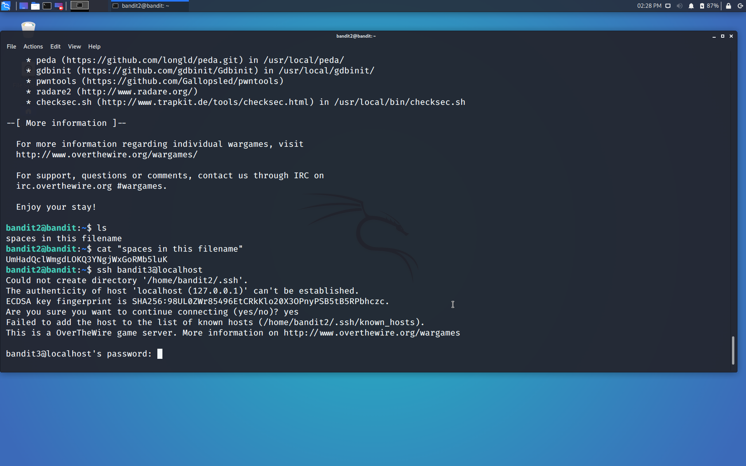

Use the command **ssh bandit3@localhost** to connect to the level 3.

Enter the password and hit enter.

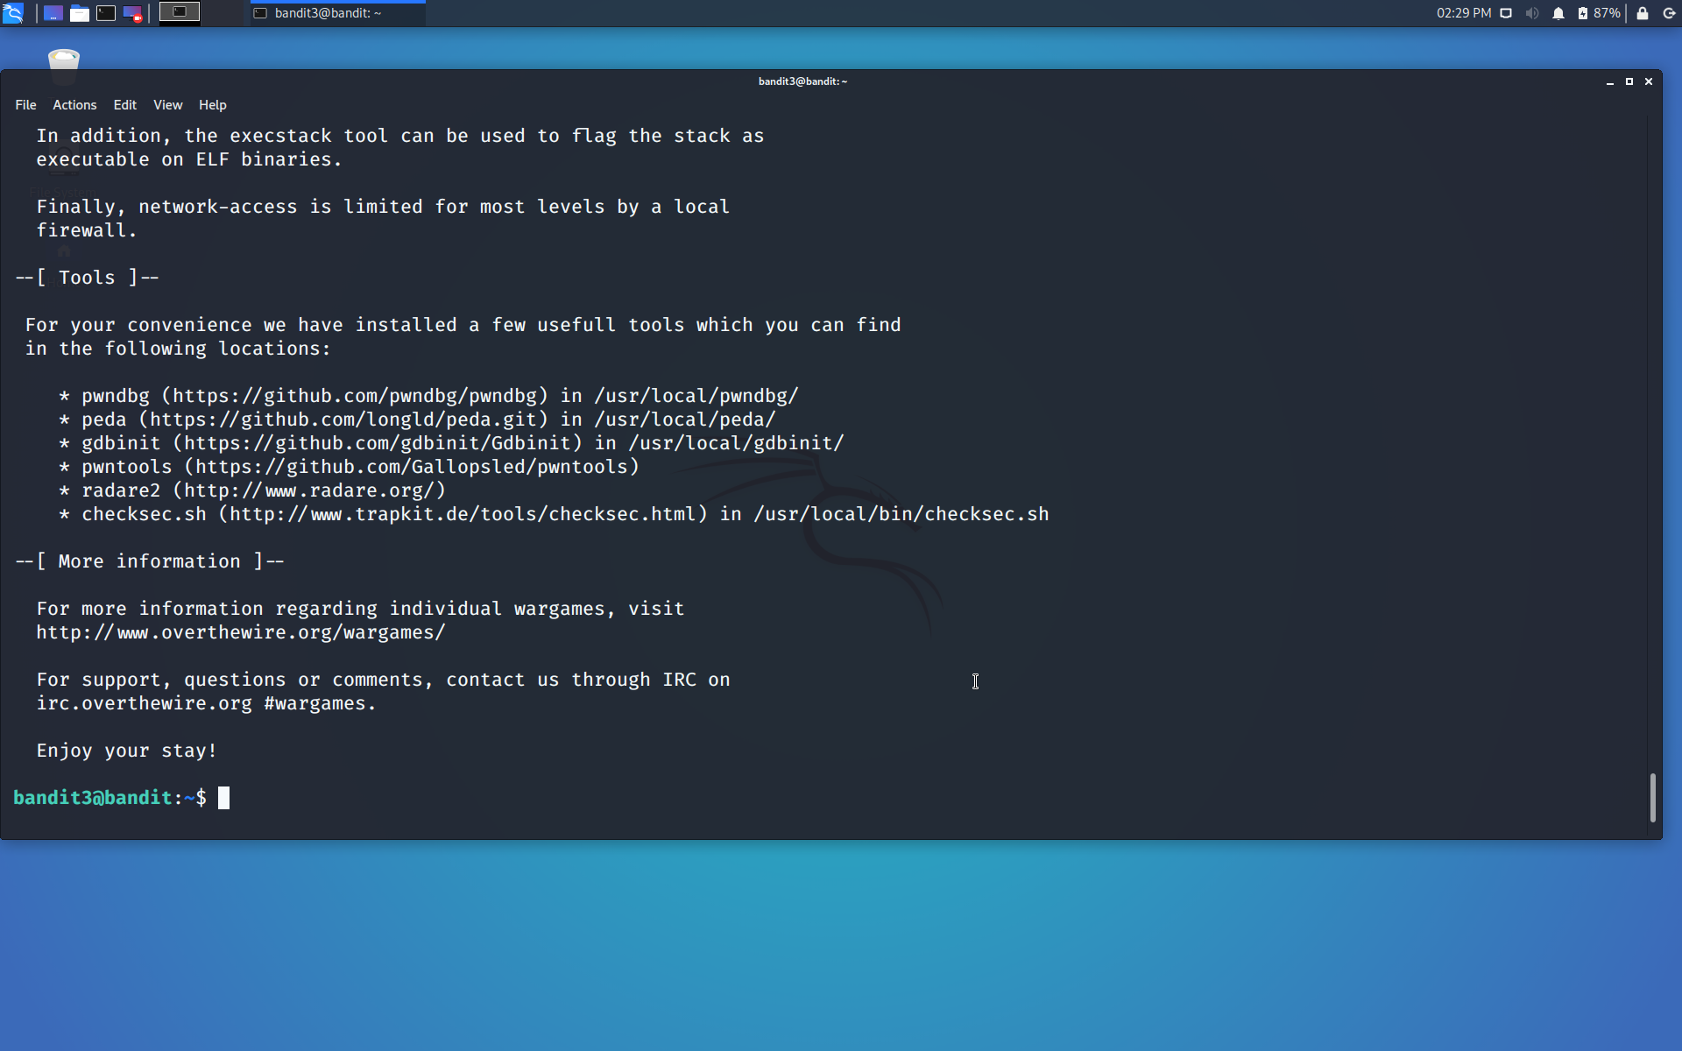

Successfully passed level 3.…